Call Stack
These features also improve the productivity during debugging. If you have multiple method calling or nested calling all over your application and during debugging, you want to check from where this method has invoked, "Call Stack" comes into the picture. The Call Stack Window shows that current method call nesting. 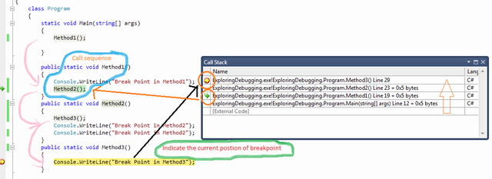
Figure: Call Stack
In Call Stack window if you clicked on any of the rows, it will point you to the actual code of line of Visual Studio Code Editor. You can also customize the call stack row view by selecting different types of columns. To customize, Right Click on the "Call Stack" window, and from the context menu, you can select or deselect the option.
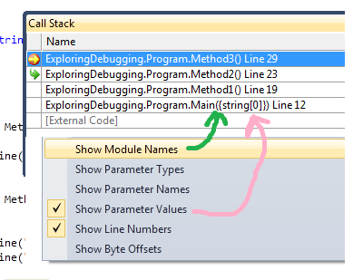
Figure: Call Stack Customization
Call stack is very much important when you have multiple methods call all across the application and one particular method throwing an exception on some particular case. At that time, you can use call stack to see from where this method is getting invoked, based on that you can fix the defect.
Apply following keys when u r looking at “call stack”
F10
F11
Shift + F11

